**LAB REPORT NO 8**



**Spring 2020**

**CSE102L Computer Programming Lab**

Submitted by:  **Muhammad Ali**

Registration No. : **19PWCSE1801**

Class Section: A

“On my honor, as student of University of Engineering and Technology, I have neither given nor received unauthorized assistance on this academic work.”

Submitted to:

**Engr. Abdullah Hamid**

(July 24, 2020)

Department of Computer Systems Engineering

University of Engineering and Technology, Peshawar

**1. Write a C++ program where you take two values in two variables from user, add the values of the two variables and put it into a third variable using a pointer. you must you only one pointer.**

#include<iostream>

using namespace std;

void add(int a, int b, int *c);

int main(){

int a,b,c;

cout<<"Enter a number :"<<endl;

cin>>a;

cout<<"Enter another number :"<<endl;

cin>>b;

add ( a,b,&c);

return 0;

}

void add(int a,int b,int *c){

*c=a+b;

cout<<*c;

}

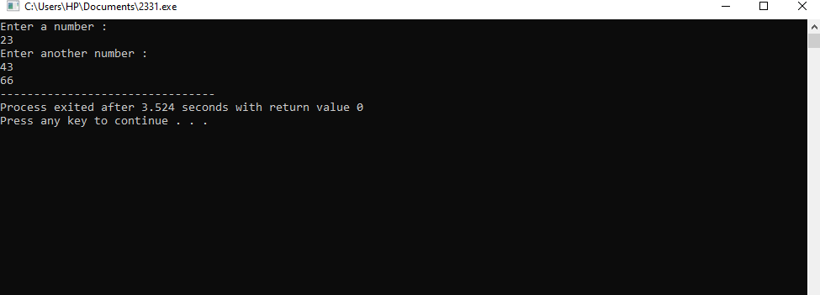

**2. Write a C++ program where you take two values from user in two variables, swaps the values of the variables using references (&amp;).**

#include<iostream>

using namespace std;

void myswap(int *x,int *y);

int main(){

int x,y;

cout<<"Enter the value of x and y :"<<endl;

cin>>x>>y;

cout<<"Before swaping x = "<<x<<endl;

cout<<"Before swaping y = "<<y<<endl;

myswap( &x ,&y);

return 0;

}

void myswap(int *x, int *y){

int temp=*x;

*x=*y;

*y=temp;

cout<<"\nAfter swaping x = "<<*x<<endl;

cout<<"After swaping y = "<<*y<<endl;

}

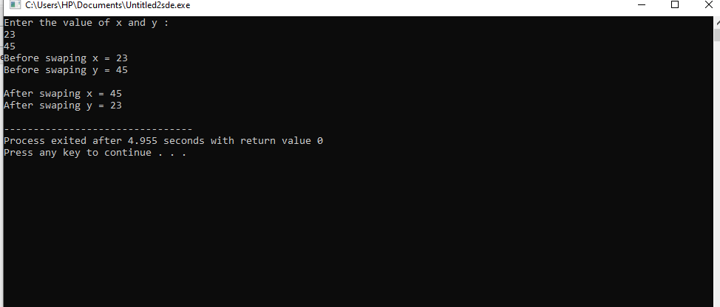

**3. Write a C++ program where you take a value in a variable from use increment that value by 5 using a pointer in a for loop and display its play using pointer.**

#include<iostream>

using namespace std;

main() {

int n, *a = &n;

cout<<"Input a number: ";

cin>>n;

for(int i = 1; i <= 5; i++) {

(*a)++;

}

cout<<*a;

}

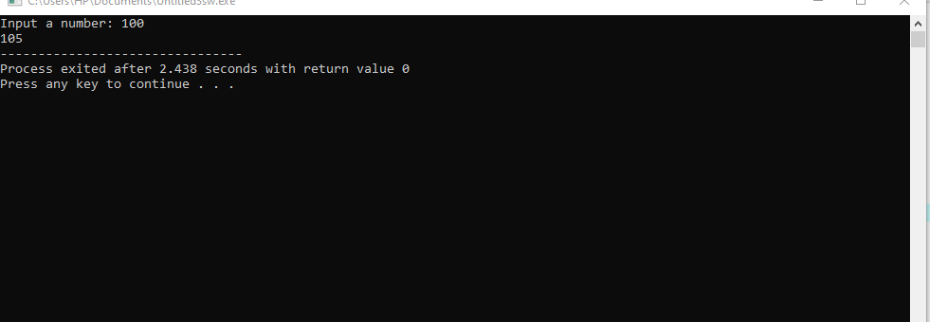

**4. Write a C++ program where you take your first name from user in a string variable using pointer edit that string to your last name and then display that string variable (your last name must be hard coded in a separate string variable).**

#include<iostream>

#include<string.h>

using namespace std;

main() {

string a, *pointer = &a, b = "Ali khan";

cout<<"First name: ";

cin>>a;

*pointer = b;

cout<<"value stored in a = "<<a;

}

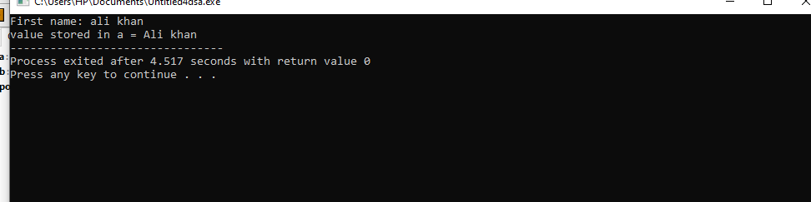

**5. Display 1 to n numbers using pointer, user must enter the n.**

#include<iostream>

using namespace std;

main() {

int a, n = 1, *b = &n;

cout<<"Input: ";

cin>>a;

while(*b <= a) {

cout<<*b<<" ";

(*b)++;

}

}

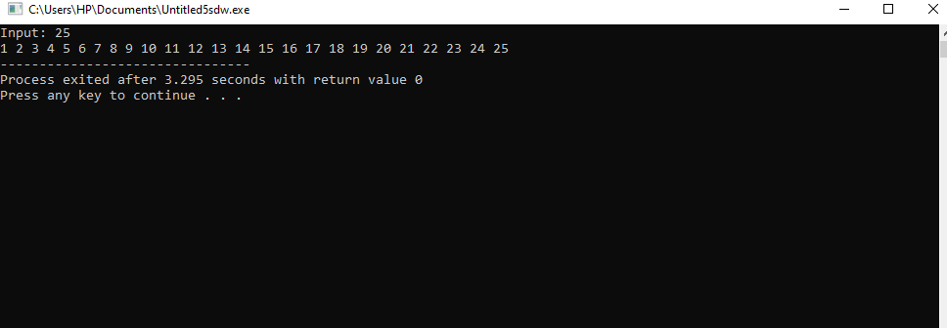

**6. Add even numbers from 1 to n using pointers user must enter n.**

**Code**:

#include<iostream>

using namespace std;

main() {

int a, b = 2, *c = &b, s = 0, *p = &s;

cout<<"Enter a number: ";

cin>>a;

while(*c <= a) {

*p += *c;

*c += 2;

}

cout<<*p;

}

